# **How to Edit the Contacts Page Content**

## Step 1: Log in to WordPress Admin Panel and Navigate to Pages

Log in to your WordPress admin dashboard. In the left sidebar menu, click on "Pages – All Pages".

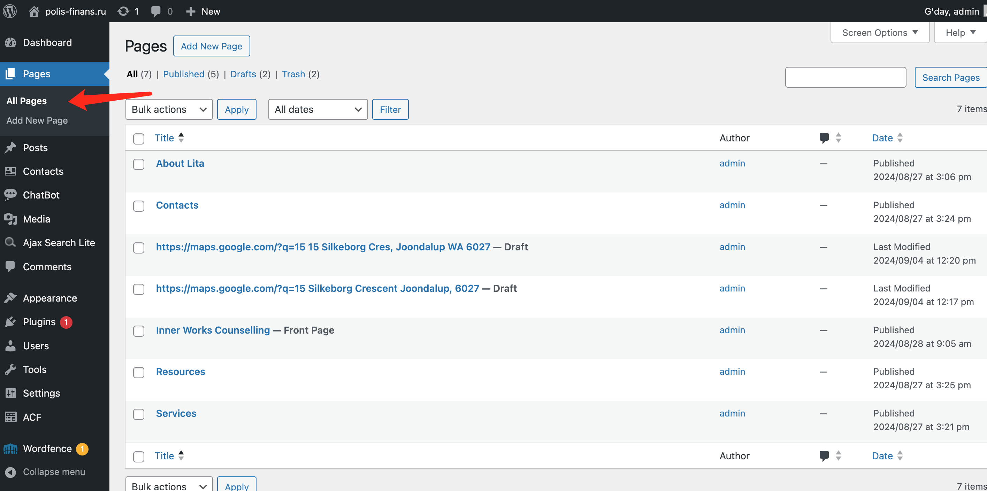

## Step 2: Locate and Edit ‘Contacts’ Page

1. On the Pages screen, locate the "Contacts" page in the list of pages. Hover your mouse over the " Contacts" page title and click "Edit" when it appears.

## Step 3: Edit / Add Content

### Existing Fields

The page editor will allow you to change the following fields:

* **Title**: Change the title by editing the text in the title field at the top.
* **Custom Fields:** The page uses custom fields to display information like the phone number, address, and counseling hours. To modify these values, you'll need to modify directly in the panel below the content.

### Edit the content

* The title is editable using the text editing toolbar that appears above the paragraph to format your text (bold, italic, link, etc.)
* Type or paste your new content directly into the paragraph block.
* Custom fields can be modified by locating the sections you want to modify and editing the text directly. For example, to change the phone number, find the line ('contact_phone') and replace the content with the new phone number.

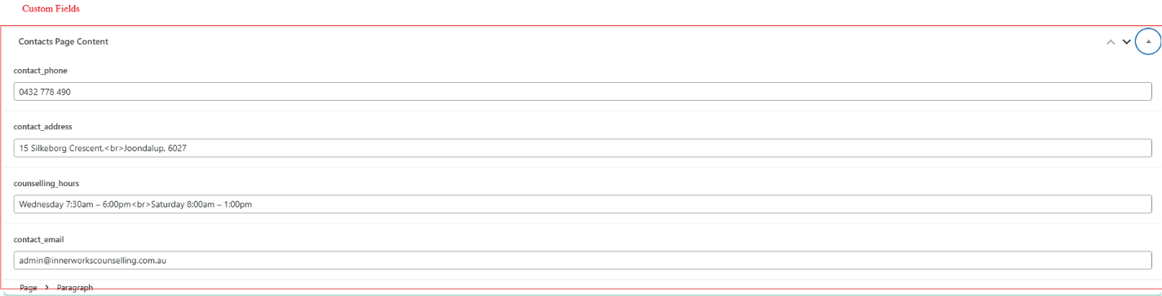

### Add new content

* Click the "+" icon at the top left of the editor to add new blocks (like paragraphs, headings, images, etc.)



### Preview and Save Changes

To preview your changes, click the laptop icon in the top right corner. This opens a dropdown menu with several options:

* Desktop: Preview how the page looks on desktop screens.
* Tablet: Preview the page layout for tablet devices.
* Mobile: See how the page appears on mobile phones.
* Preview in new tab: Opens a full preview of the page in a new browser tab.

After previewing, click the "Save" button to publish your updates. Visit your website to verify the changes appear as intended.

### Rollback

If you are not happy with your changes or you want to undo or redo changes, there is a edit panel bar in the left side of the page with tools such as:

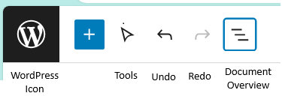

* Tools: Tools provide different interactions for selecting, navigating, and editing blocks. Toggle between select and edit by pressing Escape and Enter.
* Undo
* Redo
* Document Overview

Note: if you want to just quit without saving, just click on the WordPress Icon and confirm you want to not save your changes.

